Blue mussels Mytilus edulis L. and M. trossulus Gould in sympatry: assessment of ecological niche divergence using species distribution modeling
Running page head: “Mussel species niche divergence”
V. Khaitov* ^{1,2}, P. Safonov³, A. Zaichikova ⁴, M. Katolikova ¹ , M. Ivanov ¹, P. Strelkov ^{1,5}
¹ St. Petersburg State University, University embankment 7–9, 199034 St. Petersburg, Russia
² Kandalaksha State Nature Reserve, Lineynaya 35, 184042 Kandalaksha, Russia
³ Institute of Cytology RAS, Tikhoretsky 4, 194064 St. Petersburg, Russia
⁴ Moscow State University, Leninskie gory 1с12, 119234 Moscow, Russia
⁵ Laboratory of Monitoring and Conservation of Natural Arctic Ecosystems, Murmansk Arctic University, Kapitana Egorova 15, 183038 Murmansk, Russia
* Corresponding author
Corresponding author’s e-mail: polydora@rambler.ru
Abstract
Species distribution models (SDMs) describing the relationship between species occurrence and environmental parameters can be used to assess the ecological niche of a species. Usually applied to morphologically distinct species, SDMs are also a promising tool for describing niche partitioning in coexisting cryptic species. An example of the latter in the marine realm are blue mussels Mytilus edulis (ME) and M. trossulus (MT). Despite considerable research effort, little is known about how they share space and resources in sympatry anywhere except the Baltic Sea. Salinity, substrate, surf and proximity to harbors have been suggested as candidate factors of segregation but no general consensus has been reached. Here we assessed partial effects of these predictors on divergence of ME and MT in the White Sea littoral applying SDMs to 570 mussel samples with known taxonomic structure. We found that each of the predictors influenced spatial segregation. The most expected habitat of ME was a bottom substrate in a wind-exposed location with an average White Sea salinity (24 psu) away from ports and large rivers, while for MT it was an algal substrate in a wind-protected area with a lower salinity close to ports and large rivers. We also found that the species segregation by substrate was density-dependent: the degree of segregation positively depended on ME abundance, which indicates that ME outcompetes MT on bottom substrates. We suggest that the same predictors can drive the segregation of these two species outside the White Sea.
Key words: Mytilus; cryptic species; species distribution models; ecological niche divergence

1. INTRODUCTION
Species distribution models (SDMs) are a numerical tool describing the relationship between species occurrence and environmental parameters. They can be used to predict distribution patterns of species in space and time and to assess their ecological niche (Elith & Leathwick 2009). Joint application of SDMs to coexisting species, i.e. a community, makes it possible to describe the partitioning of their ecological niches (Ovaskainen & Abrego 2020). In other words, SDMs may describe the axes in ecological space along which coexisting species are segregated. SDMs can be built using various approaches, from regular multiple regressions to advanced machine learning (Elith et al. 2006, Caradima et al. 2019, Poggiato et al. 2021).
SDMs are usually applied to morphologically distinct species (e.g. Reiss et al. 2011, Lindegren et al. 2022), which are distinguished in routine biodiversity assessment studies. However, there is increasing evidence about coexistence of cryptic species (Bickford et al. 2007, Geller et al. 2010, Struck et al. 2018) and infraspecific taxa (Dufresnes et al. 2023). Cryptic invasions usually stand behind sympatry (Morais & Reichard 2017). Cryptic invasions often underlie sympatry Sympatry usually arises as a result of cryptic invasions (Morais & Reichard 2017). Coexisting taxa are unlikely to have identical ecological phenotypes, and an ecological niche partitioning between them can be expected (Sáez & Lozano 2005). The question how such taxa share space and resources in sympatry can be answered using SDMs (Peterson et al. 2019). This approach has already been successfully used in marine ecology (e.g. Dennis & Hellberg 2010, Lowen et al. 2019, Hu et al. 2021). The results indicate that cryptic taxa indeed have distinct ecological phenotypes. Therefore, ecological niche assessment of coexisting cryptic species, particularly those of economic, conservation or ecosystem importance, is a promising research direction.
Blue mussels (Mytilus edulis species complex) are the longest-known and best-studied cryptic species in the marine realm (Knowlton 1993, Gosling 2021). Six species that make up this complex hybridize in sympatry and are easier to distinguish genetically than morphologically (Wenne et al. 2020, Gardner et al. 2021). Blue mussels are powerful ecosystem engineers and important aquaculture objects species for aquaculture (Buschbaum et al. 2009, Gosling 2021).
The dominant species of blue mussels in the North Atlantic are M. edulis (ME) and M. trossulus (MT). Their distribution on the oceanic scale is mostly regulated by temperature and its correlates such as sea ice extent and primary production (Hayhurst & Rawson 2009, Wenne et al. 2020). Both of these species occur in the Arctic but ME is distributed further south than MT in temperate seas (Wenne et al. 2020). There are multiple zones of sympatry between ME and MT (hereafter, contact zones), from Scotland and the Gulf of Maine in the south to Greenland and Spitsbergen in the north (Wenne et al. 2020). ME and MT evolved in allopatry since the Pliocene in the Atlantic and the Pacific Ocean, respectively, and their contact zones are thought to have formed as a result of repeated MT invasions from the Pacific Ocean to the Atlantic as well as from one part of the Atlantic into another (Väinölä & Strelkov 2011, Wenne et al. 2020 and references therein).
In contact zones, ME, MT and their hybrids are often found in the same settlements (Väinölä & Strelkov 2011, Wenne et al. 2020), which are referred to as mixed settlements. Scientists generally agree that sympatric ME and MT are ecologically distinct (Riginos & Cunningham 2005, Katolikova et al. 2016, Michalek et al. 2021) and have a different economic value in aquaculture (Penney et al. 2002, Beaumont et al. 2008), but the data on the factors of their ecological segregation are fragmentary and contradictory.
The greatest progress in comparative ecological studies of ME and MT in sympatry has been made in the contact zones in the Baltic Sea, in the waters of the Kola Peninsula (White and Barents Seas) and in the West Atlantic (mainly, Gulf of Maine and New Scotland Nova Scotia). In the Baltic Sea, the brackish areas of its inner part are inhabited by MT, while the saltier areas closer to the North Sea are inhabited by ME. In the middle there is the contact zone, where mixed settlements can be dominated by hybrids, with MT gene frequency gradually increasing towards the inner Baltic (Väinölä & Strelkov 2011, Zbawicka et al. 2014, Stuckas et al. 2017). As a result, the species distribution is strongly correlated with salinity, and the role of other factors is negligible (Kijewski et al. 2019).
In the contact zones of the Kola Peninsula and the West Atlantic there are few hybrids in mixed settlements, and the spatial distribution of ME and MT is patchy on different scales, from dozens of kilometers to dozens of centimeters. The relationship between the distribution and salinity is not obvious in these contact zones, and there seems to be no simple “single-factor” pattern driver of species distribution (Riginos & Cunningham 2005, Katolikova et al. 2016, Wenne et al. 2020, Marchenko et al. 2023). Depth, fouling substrate, anthropogenic pollution levels and surf effects have been considered, apart from salinity, as possible factors affecting the segregation of ME and MT (Bates & Innes 1995, Comesaña et al. 1999, Hellou & Law 2003, Tam & Scrosati 2014, Marchenko et al. 2023) but no consensus has been reached.
In particular, in the White and the Barents Sea, the frequency of MT is greater in port areas, possibly because this species has been introduced into the region with ship traffic in historic times (Väinölä & Strelkov 2011, Katolikova et al. 2016). The only segregation factor explicitly tested in the White Sea is the substrate of littoral mussels (Katolikova et al. 2016). Adult MT is more common on fucoid algae while adult ME mostly lives directly on the bottom substrates such as mud, sand, stones and gravel. However, segregation across substrates cannot fully explain the local-scale patchiness (Katolikova et al. 2016). In the Barents Sea, no correlation with substrate has been found. However, these species have different depth preferences there: ME appears to be a more sublittoral species and MT a more littoral one (Marchenko et al. 2023).
It should be noted that some of the candidate factors of species segregation may be collinear and confound the analysis. Ports are often located in sheltered areas close to river mouths, and the effects of shipping, surf and salinity are difficult to distinguish. The effects of depth and substrate may obscure each other since fucoids, common in the littoral, are rare in the sublittoral, where they are replaced by kelps (Druehl & Green 1982).
Comparative ecological studies of ME and MT, which began as early as the 1980s (see Riginos & Cunningham 2005 for review), have been hampered by two circumstances. Firstly, it was impossible to examine large amounts of material because species identification required labor-intensive genotyping methods (Khaitov et al., 2021). Secondly, until recently there were no reliable statistical methods for modeling the distribution of sympatric taxa in the space of multiple factors and the SDM approach could not be implemented. To our knowledge, it has been applied to ME and MT only twice, in the above-mentioned studies by Kijewski et al. (2019) and Wenne et al. (2020). In both studies the machine learning techniques were used to model the macro-geographic distribution of species (technically, of allele frequencies at taxonomically informative genes) in the space of multiple climatic and oceanographic characteristics available from public databases. These methods have never been applied to modeling species distributions within contact zones.
In our previous studies we found a simple semi-diagnostic conchological trait for ME and MT (Katolikova et al. 2016). Using this trait, one could make reliable interpretations of the taxonomic structure of mixed settlements on the basis of morphotype frequencies in samples, i.e., without genotyping. This procedure was referred to as the “morphotype test” (Khaitov et al. 2021).
The aim of this study was to estimate the divergence of ecological niches between ME and MT in the White Sea littoral along environmental gradients such as substrate, salinity, surf level, and distance from ports. All these factors have been suggested as potentially influencing segregation of these two species in sympatry. Another candidate factor, depth (Marchenko et al. 2023), was not examined in our study but was controlled by sampling at the same littoral level. To achieve our aim, we examined the variability of the environmental predictors and the taxonomic structure of mussel settlements using an extensive material (95 study sites, 570 mussel samples, 55,529 mussels) and assessed the partial influence of the predictors on the distribution of proportion of MT using SDMs. Since all predictors were included in one model, collinearity could be controlled. Ideally, a model trained on reliable data should be transferable and work well on independent data. Therefore, we evaluated the predictive power of our model using testing datasets from the White and the Barents Sea. In addition, to reveal a possible competition between the two species, we checked whether the pattern of their segregation by substrate was density-dependent.
2. MATERIALS & METHODS
2.1 Study area
The study area was the Kandalaksha Bay, where all previous ME and MT studies in the White Sea have been conducted (Katolikova et al. 2016, Khaitov et al. 2018, Khaitov et al. 2023). The Bay, 185 km long, is funnel-shaped, with a highly indented coastline and numerous islands and skerries (Fig. 1). Climate is continental subarctic with 4-5 months of ice cover and the average monthly sea surface temperature in August of 13.8°C. Mean tidal range is about 2 m. Summer surface salinity is 24 psu in most of the Bay (average salinity for the White Sea) and lower in the estuarine areas (Berger & Naumov 2000). Two canals of a hydropower plant and 24 rivers with a catchment area of 141 – 12,830 km² (Median 240 km²; see Table S1 in Supplement 1) flow into the Bay, with the largest river, the Niva, entering the Bay at its very top. Due to the indented shoreline and numerous rivers, local surf and salinity gradients are pronounced (Filatov et al. 2007).
Six ports operating oceanic vessels were functioning in the area in the 20th century (Fig. 1). Two of them, both at the Bay’s top, are still in operation. The other four have been abandoned (Sailing directions of the White Sea 1932, Krasavtsev 2011) but are occasionally visited by small ships (our observations).
In 2002–2013, both ME and MT were almost ubiquitous in the Bay, but their ratio in settlements varied greatly, with ME being generally dominant (Katolikova et al. 2016). Mussels in the Bay are particularly abundant in the littoral fucoid belt (mainly Fucus vesiculosus L. and Ascophyllum nodosum L.), which is continuous 0.5-1.0 m above mean spring tide depth (Berger et al. 2001).
2.2 Modeling dataset
2.2.1 Mussel sampling and processing
Mussels were sampled at 95 sites within the littoral fucoid belt in summer months of 2011-2018 (Fig. 1). Data for 17 of these sites were included in the study by Katolikova et al. (2016), the other data are new (Table S2 in Supplement 1). The sites were chosen to describe the littoral populations of the Bay in as much detail as possible and to account for the heterogeneity of their habitat by substrate type, surf level, and distance from rivers and ports. All samples were taken within the fucoid belt. At each site, three samples from fucoid thalli (hereinafter, algal samples) and three samples from bottom substrates (bottom samples) were collected a few meters from each other using 0.25 m² and 0.025 m² frames, respectively. A greater size of the algal frame was associated with the large size of the fucoids and the need to account for their complex geometry. The frames were placed not randomly but approximately at the same depth and in such a way as to capture the dense mussel aggregations.
We used mussels with a shell length larger than 10 mm for a reliable identification of the shell morphotypes (Khaitov et al. 2021). In the bottom samples all mussels from a frame were used. In the algal samples the procedure was different. One bundle of algae, containing at least a few dozen mussels, was chosen and weighed together with the attached mussels. The rest of the algae from a frame were weighted too. Mussels from the bundle were counted and used for further analysis. The ratio between the counted number of mussels and the bundle weight was applied to the total algal weight to reconstruct the total number of mussels in the sample (Table S3 in Supplement 1). The information on the total number of mussels in algal samples was lacking for 12 of the sites, and they were excluded from the analyses which required data on mussel abundance (Model 2 and Model 3 below).
Mussel shell morphotypes were identified for all selected mussels as in Khaitov et al. (2021) based on the presence (T-morphotype) or absence (E-morphotype) of an uninterrupted strip of prismatic layer under the ligament on the inner side of the shell. T-morphotype is characteristic of MT, and E-morphotype is characteristic of ME. The proportion of morphotypes was converted to the proportion of MT (Ptros) in each sample, in pooled samples from each substrate from each site (thereafter denoted as Ptros_{Algae} and Ptros_{Bottom}) and in pooled samples from each site (thereafter Ptros_{Site}), using equation
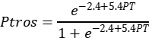
where PT is a proportion of T-morphotype.

This equation, derived from the 24 genotyped samples (in total, 1105 multilocus mussel genotypes) from the Kandalaksha Bay, accounts for the nearly linear dependence of Ptros on PT and reliably predicts Ptros over the entire salinity range in the White Sea, i.e., up to 24 psu (Khaitov et al. 2021). However, as studies in the Barents Sea have shown, this equation may overestimate Ptros at higher salinities, e.g. up to 20% at salinity around 30 psu (Khaitov et al. 2021, Marchenko et al. 2023).
2.2.2 Assessment of environmental parameters
In total, we used seven parameters describing possible influence of rivers, ports, surf and substrate on mussels (Table 1). We used three different proxies of salinity (RiverSize, DistRiver and Salinity) because, in our opinion, a single estimate of salinity at low tide could be insufficient to characterize overall salinity and river influence per se at the sampling sites. Salinity was measured directly with an accuracy of 1 psu using an Atago S/Mill-E refractometer. To classify rivers by size (RiverSize), the data from ESM (Table S1 in Supplement 1) were used. To calculate Fetch, the R-package “waver” (Marchand & Gill 2018) was applied to regional geographic map shape-files.
2.3 Testing datasets
Three datasets were used as testing ones, one from the same area of the White Sea and two from the Barents Sea. “Kandalaksha littoral” dataset contained 23 samples from 12 littoral sites in the Kandalaksha Bay (Fig. S1 in Supplement 2). We took only algal samples at four sites, only bottom samples at four other sites and samples from both substrates at the remaining four sites (Table S4 in Supplement 1). Environmental parameters were assessed in the same way as for the modeling dataset.
“Tyuva littoral” and “Tyuva sublittoral” testing datasets were extracted from the published data of Marchenko et al. (2023). These authors mapped in detail the distribution of Ptros in mussel settlements of the 3-km-long Tyuva Inlet in the Kola Bay of the Barents Sea (Fig. 1) sampled in 2009-2010. Ptros was predicted either by direct genotyping or from morphotype frequencies using the formula derived for local populations existing under salinities higher than in the White Sea (Marchenko et al. 2023). They provided a number of environmental characteristics including depth, Salinity, cover of macrophytes in rank scale, and dominant algal species (usually, kelps in the sublittoral and fucoids on the littoral) for each sampling site. “Tyuva littoral” set contained samples from all 23 littoral sites from the depth range corresponding to the fucoid belt (0.5-1.5 m above mean spring tidal depth, Marchenko et al. [2023]; note that the position of fucoid belt in the Barents Sea differs from that in the White Sea due to the different tidal amplitude). “Tyuva sublittoral” contained samples from all 15 sublittoral sites (depth range from -0.5 to -3.5 m). Since the substrate of mussel fouling was not registered during sampling, we classified samples into bottom and algal ones by the algal cover in the sites (ranks 1-3 and 4-5, correspondingly). The remaining environmental parameters were assessed as for the modeling dataset, with the nearest port in Ekaterininskaya Gavan Bight considered as active and the river Tyuva flowing into the inlet as a large one.
2.4 Statistical analysis
All the data were processed using the statistical programming language R 4.05 (R Core Team 2023).
2.4.1 Dependency of Ptros on environmental parameters in modeling dataset (Model 1)
We used generalized additive mixed model (GAMM, Wood 2017) as a modeling technique, which has been shown to work well for SDM construction (Elith et al. 2006). One of the strengths of this approach is that additive models assume that the relationship between the dependent variable (in our case, Ptros) and continuous predictors is not necessarily linear but may be curvilinear (Austin 2002). The weakness of the approach is that it does not provide a direct assessment of either relative or absolute importance of factors.
GAMM fitted (hereafter, Model 1) was based on beta-binomial residuals distribution and the restricted maximum likelihood method for estimation of the parameters. Smoothers for all continuous predictors were fitted using cubic basic splines. Categorical predictors were included as parametric terms in the model. Site was considered as a random factor. The function gam() from the package “mgcv” (Wood 2017) was used to fit the model.
To check for all predictors’ collinearity in Model 1 and other models, we calculated the variance inflation factor (VIF, Fox & Monette 1992), considering the value less than 3.5 as acceptable (Quinn & Keough 2002). To verify that Model 1 met the assumptions of sampling independence, we examined the presence of residuals’ spatial autocorrelation by means of spline correlogram construction (Bjørnstad & Falck 2001) with the function spline.correlog() from the package “ncf” (Bjornstad 2022) and found no evidence of spatial autocorrelation. We also considered the model residuals in relation to year of sampling and found no significant patterns.
2.4.2 Dependence of abundance of mussels of different morphotypes on environmental parameters in a modeling dataset (Model 2)
The relationships between the taxonomic structure and the predictors were further investigated using abundances of mussels of different morphotypes. This means that we equated morphotypes with species. However, this assumption should not have crucially biased the results of the analysis, given the proportional relationship between PT and Ptros in mussel settlements in the study area (Khaitov et al. 2021). The mean abundances of mussels of E- and T-morphotypes across samples from each site (from both substrates) were log-transformed and used as the dependent variable in Model 2. The model was constructed as a generalized additive one (GAM) with Gaussian residuals’ distribution and included the factor Morphotype, the same set of predictors as in Model 1 except Substrate and Site, and interactions between Morphotype and other predictors.

2.4.3 Association between Ptros, substrate and mussel abundance
The ultimate goal of the analysis was to find out how the segregation of ME and MT between algal and bottom substrates depended on the abundance of each species on each substrate. For each site we calculated the difference between proportion of MT in algal and bottom samples: Dif = Ptros_{Algae} - Ptros_{Bottom}. The obtained Diff values were used as a dependent variable in Model 3, which was constructed as GAM with Gaussian residuals’ distribution.
Assessing the dependence of Diff on Ptros_{Site}, we could not directly operate with densities of morphotypes because they were collinear on different substrates (see Results). Therefore, we performed principal component analysis for the abundance matrix of T- and E-morphotypes on algal and bottom substrates and used PC1 and PC2 values as proxies of morphotype abundances, along with Ptros_{Site}, in Model 3.
2.4.4 Assessment of predictive power of Model 1
To check whether Model 1 could be used to predict the dominant species in bottom and algal samples at a site with known environmental parameters, MT (Ptros>0.5) or ME (Ptros<0.5), we used all the parameters from Model 1 to predict Ptros_{Algae} and Ptros_{Bottom} for each site within the modeling dataset and within each of the three testing datasets. The predicted values were categorized into those greater than 0.5 and those smaller than 0.5 and considered to be classifiers for detecting MT- or ME-dominated samples. The receiver operating characteristics (ROC) followed by the analysis of the area under the curve (AUC, Fielding & Bell 1997, Fawcett 2006) were used to evaluate the performance of the models. We considered AUC greater or equal to 0.7 as acceptable discrimination (Hosmer et al., 2013). Function roc() from the package “pROC” (Robin et al. 2011) was used.
- RESULTS
Ranges and median values of the continuous predictors are summarized in Table 1. While the distribution of Fetch and Salinity values was highly variable, the most wind-exposed sites were located on the southeastern coast of the Bay and on open shores of the islands in its top (Fig. 1 A) while the most desalinated areas were located in the very top of the Bay (Fig. 1 C). Expectedly, Salinity tended to decrease towards river mouths (Fig. S2 A in Supplement 3) and was lower closer to large rivers than to small ones (Fig. S2 B in Supplement 3). Sites close to ports tended to have lower Fetch (Fig. S2 C in Supplement 3), but no association between DistPort and Salinity was observed (Fig. S2 D in Supplement 3). All Pearson’s correlations between Salinity, DistRiver, DistPort and Fetch were rather low (Table S5 in Supplement 1), the largest being that between Fetch and DistPort (r = 0.525).
A striking feature visible on maps of Ptros distribution across algal and bottom substrates is the universally elevated proportion of MT on the former (Fig. 1 D-G). While spatial distribution of Ptros was highly variable, its maximum values on both substrates were observed in the Bay’s top and in some deep inlets, while its minimum values were observed along the open part of the southeastern coast (Fig. 1 D-G). It is difficult to discern relationships between Ptros and any environmental predictors other than substrate in the small-scale maps shown in Figure 1. For this purpose, it is necessary to consider Model 1.
3.1 Relationship of Ptros and environmental parameters evaluated by Model 1
Although some non-zero pairwise correlations between environmental factors were found (see above), VIF values calculated for the predictors were generally low (maximal VIF being that for Fetch, 1.76). This result means that the collinearity between the predictors was negligible, i.e., they did not mask each other’s influence.
Model 1 explained 77% of the total deviance. It revealed a significant dependency of Ptros on all predictors except DistRiver. Effective degrees of freedom (edf) for DistPort and Fetch were close to one, indicating the linear dependence of Ptros on them. In contrast, the dependence on the third continuous predictor, Salinity, was curvilinear (edf > 2, Table 2).
According to the model, Ptros decreased both with DistPort (Fig. 2 E) and with Fetch (Fig. 2 G). This means that the proportion of MT was higher near ports and in surf-protected areas. PortStatus also had a significant effect: predicted Ptros was higher near active ports than near abandoned ones (Fig. 2 I). The curvilinear dependence of Ptros on Salinity can be described as follows: predicted Ptros decreases with salinity in the range from low to about 24 psu (average salinity in the White Sea) and increases again at higher salinities (up to 30 psu)(Fig. 2 A). In addition, predicted Ptros was higher near large rivers than near small ones (Fig. 2 I). Finally, Ptros was higher on algal substrates than on bottom ones (Fig. 2 I, see also Fig 1 D-F).
3.2 Dependence of abundance of mussels of different morphotypes on environmental parameters evaluated by Model 2
The results of Model 2 were in complete good agreement with those of Model 1, the pattern of association was the same for all the predictors, i.e., Salinity (Fig. 2 B), RiverSize (Fig. 2 J), DistPort (Fig. 2 F), PortStatus (Fig. 2 J), and Fetch (Fig. 2 H) (see Table S6 in Supplement 1 for all model parameters). In addition, they revealed an asymmetry in the responses of the two species to some of these predictors. While the abundance of T-morphotypes did not vary with Salinity, that of E-morphotypes dropped at low salinity (Fig. 2 B). On the other hand, the abundance of E-morphotypes slightly varied with Fetch and DistPort, while that of T-morphotypes strongly decreased both with the distance from ports (Fig. 2 F) and with surf level (Fig. 2 H).
3.3 Dependency of Ptros on substrate and mussel abundance evaluated by Model 3
The principal component analysis of the abundance matrix of T- and E- morphotypes revealed a high positive correlation of PC1 (explained 62% of total variation) with abundances of T-morphotypes and of PC2 (20% of total variation) with abundances of E-morphotypes on both substrates (Fig. 3 B, C). Thus, the abundance of conspecific morphotypes varied consistently on different substrates (see also Fig. 1 D, F). Therefore, PC1 and PC2 can be considered as proxies of MT and ME abundance, respectively.
Parameters of Model 3, which explained 31% of the deviance, are provided in ESM (Table S7 in Supplement 2). Figure 3 demonstrates how the difference between MT proportion on algal and bottom substrates (Diff) depends on MT prevalence at the site (Ptros_{Site}) and mussel abundances in terms of PCs according to the model. The dependence of Diff on Ptros_{Site} was significant (p < 0.001) and, expectedly, bell-shaped, with minimal values at sites absolutely dominated by ME or MT (Ptros close to 0 or 1) and maximal at sites with equal presence of both species (Fig. 3 A). This means that maximum difference in Ptros on bottom and algae substrates was observed in the settlements where the two species are represented in equal proportions. Dependence of Diff on PC1 was marginally significant (p = 0.087) and tended to decrease with increasing PC1 (Fig. 3 B). The dependence of Diff on PC2 was significantly positive (p = 0.011, Table S6 in Supplement 2, Fig. 3 C). This means that the species were strongly segregated by substrates at sites with a high ME abundance, which highly correlate with PC2, but not at sites with a high MT abundance (high correlation with PC1).
3.3 Assessment of predictive power of Model 1
Model 1 fit well for the “Kandalaksha littoral” testing dataset (AUC=0.85 vs AUC=0.84 for modeling dataset). It classified the samples into ME- and MT-dominated ones fairly well, with the exception of a few false negatives, i.e., sites unpredictably dominated by MT (Fig. 4 A, B). Its predictive power for the two testing sets from the Barents Sea was lower but acceptable: AUC = 0.71 for “Tyuva littoral” and AUC=0.69 for “Tyuva sublittoral”. In contrast to the “Kandalaksha littoral” testing dataset, most of the false results were positive.
- DISCUSSION
Almost all environmental predictors considered in our study — namely, surf level, distance to the port, status of the port, salinity at low tide, size of the nearest river and fouling substrate — influenced the distribution of Mytilus edulis (ME) and M. trossulus (MT) in the White Sea. The differences in the distribution reflected the partial divergence of ecological niches of these two species.
4.1 Ecological niche partitioning between MT and ME in the Kola contact zone
We showed that the most expected habitat of ME in the White Sea littoral was a bottom substrate in a surf-exposed location with a surface salinity of 24 psu (average for the White Sea) situated away from ports and large rivers. The most expected habitat of MT was an algal substrate in a surf-protected location with a salinity lower than the White Sea average situated close to active ports and large rivers. While differences associated with substrate and distance to ports have been previously noted in the White Sea (Väinölä & Strelkov 2011, Katolikova et al. 2016), those associated with salinity and surf exposure were first uncovered in this study.
4.1.1 Segregation by salinity
In the Baltic Sea MT is adapted to an extremely low salinity (Knöbel et al. 2021, Wiesenthal et al. 2025). Comparative experimental ecophysiological data on MT and ME elsewhere are inconclusive scarce (Gardner & Thompson 2001, Qiu et al. 2002, Sokolova et al. 2024) Before our study, there has been no convincing evidence of segregation of these species by salinity in contact zones outside the Baltic (Moreau et al. 2005, Riginos & Cunningham 2005, Katolikova et al. 2016, Marchenko et al. 2023). For the White Sea, this lack of evidence could be due to at least three reasons. Firstly, the role of salinity may be masked by other factors such as distance to ports. This seems particularly plausible in the light of our data that MT in the White Sea is a euryhaline species forming mass settlements in the entire salinity range recorded in our study, while ME is much less abundant at salinity below 15 psu (Fig. 2B). Secondly, in contrast to the Baltic, there are no broad geographic salinity gradients in the White Sea, only local ones.
The third reason is the curvilinear dependence of the proportion of MT in mixed settlements (Ptros) on salinity: Ptros increases not only when the salinity is reduced but also when it is extremely high for the White Sea (up to 30 psu, Fig. 2 B). This nonlinearity, which may prevent the dependence from being detected, can be explained in two ways. On the one hand, local summer surface salinity above 24 psu in the Kandalaksha Bay, supposedly associated with irregular episodes of upwelling (Dale & Prego 2003), may be a nonspecific stress for littoral animals adapted to lower salinity. MT may be more tolerant to this stress. On the other hand, as shown in detailed studies at the Barents Sea (Khaitov et al. 2021, Marchenko et al. 2023), the method of predicting Ptros (“morphotype test”) used in our study may overestimate it at salinities close to 30 psu. Therefore, we cannot rule out the possibility that the increased Ptros at sites with a high salinity is an artifact.
4.1.2 Non-random distribution depending on distance to ports
The association of MT with harbors in the White and the Barents Sea may be associated with its invasion with maritime transport from the western Atlantic in the 20th century (Väinölä & Strelkov 2011). It has also been hypothesized that MT is more resistant to anthropogenic pollution and is better adapted to disturbed habitats than ME (Katolikova et al. 2016). Our observation that MT frequency is lower near abandoned ports than near active ones is consistent with this hypothesis. However, the propagule pressure of MT may have decreased near abandoned harbors in recent decades, which could affect the size of its populations.
4.1.3 Segregation by surf level
Segregation of ME and MT by surf level may be due to the well-known differences in the mechanical properties of their shells and the ability to form dense aggregations. Segregation of ME and MT by surf level (ME is more common in localities exposed to surf, while MT is more common in sheltered areas) may be due to the well-known differences in the mechanical properties of their shells and the ability to form dense aggregations. ME has thicker, heavier and less flexible shells (Beaumont et al. 2008, Michalek et al. 2021) and is more inclined to form tight clumps (Liu et al. 2011). These features may be adaptive on exposed coasts. Theoretically, the distribution of ME and MT by surf level as well as substrate may also be affected by differences in byssus secretion and attachment strength. Unfortunately, there are no comparative data on this topic.
4.1.4 Segregation by substrate
Segregation by substrate may be explained by the same differences as segregation by surf level. Segregation by substrate (ME is more common on bottom substrates, while MT is more common on algal ones) may be explained by the same differences as segregation by surf level. Other things being equal, MT, with its thin fragile shells, should be lighter than ME (Michalek et al. 2021) and thus better suited to life on algae. In addition, fucoid thalli may serve as shock absorbers (Katolikova et al. 2016) and provide shelter from starfish selectively preying on MT in mixed settlements (Khaitov et al. 2018, Khaitov et al. 2023). By the same token, denser aggregations formed by ME are more adaptive on the bottom than on algae.
4.1.5 Competition for substrate
Whatever historical, physiological, morphological, behavioral and other features influence the segregation of MT and ME, interspecific competition may also be involved. Assessing the role of mussel abundance in the segregation across substrates, we found that MT abundance did not significantly affect it but ME abundance did: as the latter increased, the degree of segregation increased, too (Fig. 3 B, C). In our opinion, this pattern results from the divergence of the realized species niches: ME outcompetes MT on bottom substrates displacing it to algal thalli. However it my be, we have shown that substrate is an important factor in the segregation of the inches of the two mussel’s species.
Spatial segregation of sympatric mussels by substrates, which is apparently density-dependent, is evident at the level of tens of centimeters (Katolikova et al. 2016). Direct analogies for segregation at such a small scale can be found in other attached organisms, terrestrial plants (Raventós et al. 2010). A biologically generated spatial pattern model (Pacala & Levin 1997, Amarasekare 2003) relates inter-specific segregation with the intra-specific clustering in competing species. Our findings suggest that this model can also be applied to mussels.
4.2 Predictive power of SDM
The ability of our model to classify sites into ME- and MT-dominated ones in an independent testing dataset from the White Sea was high (AUC = 0.85). Therefore, we assume that the predictors included in the model explain most of the variation in species distribution within the littoral fucoid belt in the White Sea.
The worst, though formally satisfactory predictive value of the model for the Barents Sea data (AUC ≈ 0.7) may be due to the following reasons. The model's predictive performance for the Barents Sea data (AUC ≈ 0.7), while formally acceptable, was comparatively lower than in other regions. This may be attributed to the following factors.Firstly, it may be associated with a large depth range of the sampling sites, considering that distribution of ME and MT in the Tyuva Inlet by depth is non-random (Marchenko et al. 2023). The second reason may be a coarser categorization of the Barents Sea samples into algal and bottom ones. Since fouling substrate was not taken into account during sampling, we predicted it based on the projective cover of algae at the sampling site. Thirdly, we do not know whether the two species are non-randomly distributed across bottom and algal substrates in the sublittoral, where fucoids are replaced by kelps. The fourth reason could be a narrow variation in values of DistPort, DistRiver, and Fetch in the small Tyuva Inlet in comparison with the Kandalaksha Bay.
Finally, the fact that SDM tended to overestimate Ptros in the Barents Sea data (false positive predictions) is consistent with the observation that the proportion of MT has been declining in the study area in the 2010s under seemingly stable environmental conditions in terms of predictors included in our model (Marchenko et al. 2023). This observation suggests the presence of some yet unstudied factors regulating the taxonomic structure.
4.3 Ecological niche partitioning between MT and ME in the Kola contact zone as compared to other zones
Blue mussels are a challenging model for studying ecological niche partitioning between cryptic species in sympatry due to their wide distribution, biogeographic history and hybridization. ME and MT play similar ecological roles in their native oceans, Atlantic and Pacific, respectively (compare Commito & Dankers 2001 and Bodkin et al. 2018) and may inherently have overlapping fundamental ecological niches. Contact zones between these species in the Atlantic can be considered as ecological (and evolutionary) experiments, set in strikingly different environments (from Baltic to Spitsbergen) at different times (from late post-glacial to the historical period, Väinölä & Strelkov 2011, Wenne et al. 2020, and references therein). The design of these experiments was possibly different too, because in some zones the original settler could be ME and in others, MT. In addition, competition (ecological character displacement, Pfennig & Pfennig 2009), hybridization (reinforcement of prezygotic reproductive isolation, Lukhtanov 2011) and introgression (adaptive introgression, Hedrick 2013) could influence the divergence of their ecological phenotypes differently in different zones. These considerations suggest that the zones should differ, and this hypothesis has been a recurrent theme in genetic research on blue mussel contact zones (Riginos & Cunningham 2005, Bierne et al. 2011, Fraı̈sse et al. 2016). Nevertheless, we believe that the differences between ME and MT are more fundamental and that conspecific ecological phenotypes in different zones should thus be similar, producing comparable patterns in species distributions. Some results of this study support this hypothesis.
The observation that MT frequency is elevated in low-salinity habitats not only in the Baltic but also in the White Sea seems to resolve the old conundrum about seemingly contrasting salinity adaptations of the Baltic and other Atlantic MT populations (e.g. Riginos & Cunningham 2005, Katolikova et al. 2016, see also above). Further, an increased MT frequency has been repeatedly observed in calm and freshened waters e.g., in the tops of fjords near Bergen in Norway (Ridgway & Nævdal 2004) and Uummannaq in Greenland (Wenne et al. 2020) and in Loch Etive in Scotland (Beaumont et al. 2008), which is hardly a coincidence. Our observations indicate that this combination of weak surf and low salinity is also favorable for MT in the White Sea.
With the exception of salinity in the Baltic, none of the predictors affecting segregation of ME and MT in the White Sea have been convincingly shown to act in other contact zones. Data on surf are inconsistent (compare Bates & Innes 1995, Comesaña et al. 1999, Tam & Scrosati 2014 and this study), and data on substrates are absent. If different preferences of ME and MT for surf level and substrates are indeed associated with their morphological and behavioral differences (Katolikova et al. 2016; this study), these preferences should be omnipresent. Ad hoc studies in other contact zones might throw light on this matter. It would also be interesting to examine the differences between ME and MT in tolerance to stress, particularly anthropogenic pollution, e.g., in harbors (see discussion in Brooks et al. 2015 and Beyer et al. 2017).
4.4 Strengths and weaknesses of our approaches to the study of sympatric mussels
The methods used in our study have certain limitations. We identified the mussels with the help of the “morphotype test”, which does not permit a direct assessment of species abundances and does not identify hybrids as a separate category. The latter limitation is not particularly significant in the Kola zone, where hybrids are relatively scarce (Väinölä & Strelkov 2011, Wenne et al. 2020), but may compromise studies in other contact zones, where hybrids may play an important ecological role (e.g., Schwartz et al. 2024).
Although ME and MT differ everywhere in morphotype frequencies, the magnitude of the differences varies between contact zones and between habitats with different salinities in the Arctic (Khaitov et al. 2021). This means that the “morphotype test” must be calibrated before use in a new area (see Khaitov et al. 2021 for recommendations). Multilocus genotyping, while still too costly for processing dozens of thousands of specimens needed for SDM, remains the gold standard of taxonomic assessment in blue mussels.
We did not account for some potential predictors affecting species segregation such as depth (Marchenko et al. 2023), predators (Khaitov et al. 2018, Khaitov et al. 2023) or temperature (Kijewski et al. 2019). Moreover, some of our predictors could have been estimated more carefully (for example, bottom salinity at high tide could be more informative for littoral mussels than salinity at low tide). However, since most of our predictors were shown to be significant, they should not be ignored in future studies.
The correlative approach used in our study does not allow a direct assessment of either relative or absolute importance of factors. For instance, we cannot say whether salinity or substrate is more crucial. However, the take-home message from our research is that there is no single “leading” factor determining the distribution of ME and MT, contrary to the idea that has dominated the field since the pioneering studies in the Baltic (e.g. Gardner & Thompson 2001, Ridgway & Nævdal 2004, Riginos & Cunningham 2005, Śmietanka et al. 2014).
The limitations discussed above do not detract from the fact that, as shown in our study, SDMs may be a useful tool for the study of distribution of ME and MT in sympatry. Their obvious benefits include the possibility to analyze the distribution of the species in the space of multiple predictors simultaneously, the possibility to control the collinearity of the predictors and the lack of necessity to treat dependencies as linear.
Promising directions of further research on niche partitioning in sympatric mussel species are, in our opinion, as follows. The use of taxonomic methods allowing direct assessment of abundances of species and their hybrids would elucidate the nature of competition between them all. Incorporation of additional environmental factors into SDMs might yield surprising results. Further, it would be worthwhile to have a closer look at different spatial scales, down to the smallest one, in the segregation of these two mussel species. Finally, a parallel study in different contact zones would reveal common and zone-specific patterns. The classical review on the divergence of ecological niches of ME and MT in different contact zones (Riginos & Cunningham 2005) is 20 years old. The time is ripe for a new survey, and our observations from the Kola zone may prove useful.
ACKNOWLEDGEMENTS
We thank all participants of our expeditions, especially Gita Paskerova and Eugene Genelt-Yanovsky, for their help in fieldwork. We are deeply grateful to Natalia Lentsman for the English language assistance during the preparation of the manuscript. We would like to express our special gratitude to the administration of the Kandalaksha State Nature Reserve, where a significant part of the material was collected, for comprehensive assistance. This study was supported by the Russian Science Foundation, grant no. 19-74-20024.
LITERATURE CITED
Amarasekare P (2003) Competitive coexistence in spatially structured environments: A synthesis. Ecology Letters 6:1109–1122.
Austin MP (2002) Spatial prediction of species distribution: an interface between ecological theory and statistical modelling. Ecological modelling 157:101–118.
Bates J, Innes D (1995) Genetic variation among populations of Mytilus spp. in eastern Newfoundland. Marine Biology 124:417–424.
Beaumont AR, Hawkins MP, Doig FL, Davies IM, Snow M (2008) Three species of Mytilus and their hybrids identified in a Scottish Loch: natives, relicts and invaders? Journal of Experimental Marine Biology and Ecology 367:100–110.
Berger V, Dahle S, Galaktionov K, Kosobokova X, Naumov A, Rat’kova T, Savinov V, Savinova T (2001) White Sea. Ecology and Environment. St-Petersburg-Tromso: Derzavets Publishers.
Berger VY, Naumov A (2000) General features of the White Sea. Berichte Polarf 359:3–9.
Beyer J, Green NW, Brooks S, Allan IJ, Ruus A, Gomes T, Bråte ILN, Schøyen M (2017) Blue mussels (Mytilus edulis spp.) as sentinel organisms in coastal pollution monitoring: A review. Marine Environmental Research 130:338–365.
Bickford D, Lohman DJ, Sodhi NS, Ng PKL, Meier R, Winker K, Ingram KK, Das I (2007) Cryptic species as a window on diversity and conservation. Trends in Ecology and Evolution 22:148–155.
Bierne N, Welch J, Loire E, Bonhomme F, David P (2011) The coupling hypothesis: why genome scans may fail to map local adaptation genes. Molecular ecology 20:2044–2072.
Bjornstad ON (2022) ncf: Spatial Covariance Functions. R package version 1.3-2.
Bjørnstad ON, Falck W (2001) Nonparametric spatial covariance functions: Estimation and testing. Environmental and Ecological Statistics 8:53–70.
Bodkin JL, Coletti HA, Ballachey BE, Monson DH, Esler D, Dean TA (2018) Variation in abundance of Pacific blue mussel (Mytilus trossulus) in the Northern Gulf of Alaska, 2006–2015. Deep Sea Research Part II: Topical Studies in Oceanography 147:87–97.
Brooks SJ, Farmen E, Heier LS, Blanco-Rayón E, Izagirre U (2015) Differences in copper bioaccumulation and biological responses in three Mytilus species. Aquatic Toxicology 160:1–12.
Buschbaum C, Dittmann S, Hong JS, Hwang IS, Strasser M, Thiel M, Valdivia N, Yoon SP, Reise K (2009) Mytilid mussels: Global habitat engineers in coastal sediments. Helgoland Marine Research 63:47–58.
Caradima B, Schuwirth N, Reichert P (2019). From individual to joint species distribution models: A comparison of model complexity and predictive performance. Journal of Biogeography 46:2260-2274.
Comesaña AS, Toro JE, Innes DJ, Thompson RJ (1999) A molecular approach to the ecology of a mussel (Mytilus edulis - M. trossulus) hybrid zone on the east coast of Newfoundland, Canada. Marine Biology 133:213–221.
Commito JA, Dankers NM (2001) Dynamics of spatial and temporal complexity in european and north american soft-bottom mussel beds. In: Ecological comparisons of sedimentary shores. Springer, p 39–59
Dale AW, Prego R (2003) Tidal and seasonal nutrient dynamics and budget of the Chupa Estuary, White Sea (Russia). Estuarine, Coastal and Shelf Science 56:377–389.
Dennis AB, Hellberg ME (2010) Ecological partitioning among parapatric cryptic species. Molecular Ecology 19:3206–3225.
Druehl LD, Green JM (1982) Vertical distribution of intertidal seaweeds as related to patterns of submersion and emersion. Marine Ecology Progress Series 9:163–170.
Dufresnes C, Poyarkov N, Jablonski D (2023) Acknowledging more biodiversity without more species. Proceedings of the national Academy of Sciences 120:e2302424120.
Elith J, H. Graham C, P. Anderson R, Dudík M, Ferrier S, Guisan A, J. Hijmans R, Huettmann F, R. Leathwick J, Lehmann A, Li J, G. Lohmann L, A. Loiselle B, Manion G, Moritz C, Nakamura M, Nakazawa Y, McC. M. Overton J, Townsend Peterson A, J. Phillips S, Richardson K, Scachetti-Pereira R, E. Schapire R, Soberón J, Williams S, S. Wisz M, E. Zimmermann N (2006) Novel methods improve prediction of species’ distributions from occurrence data. Ecography 29:129–151.
Elith J, Leathwick JR (2009) Species Distribution Models: Ecological Explanation and Prediction Across Space and Time. Annual review of ecology, evolution, and systematics 40:677–697.
Fawcett T (2006) An introduction to ROC analysis. Pattern Recognition Letters 27:861–874.
Fielding AH, Bell JF (1997) A Review of Methods for the Assessment of Prediction Errors in Conservation Presence/Absence Models. Environmental conservation 24:38–49.
Filatov N, Pozdnyakov D, Johannessen OM, Pettersson LH, Bobylev LP (2007) White Sea: its marine environment and ecosystem dynamics influenced by global change. Springer Science & Business Media.
Fox J, Monette G (1992) Generalized collinearity diagnostics. Journal of the American Statistical Association 87:178–183.
Fraı̈sse C, Belkhir K, Welch JJ, Bierne N (2016) Local interspecies introgression is the main cause of extreme levels of intraspecific differentiation in mussels. Molecular Ecology 25:269–286.
Gardner JPA, Thompson RJ (2001) The effects of coastal and estuarine conditions on the physiology and survivorship of the mussels Mytilus edulis, M. trossulus and their hybrids. Journal of Experimental Marine Biology and Ecology 265:119–140.
Gardner JP, Oyarzun PA, Toro JE, Wenne R, Zbawicka M (2021) Phylogeography of Southern Hemisphere blue mussels of the genus Mytilus: evolution, biosecurity, aquaculture and food labelling. In: Oceanography and marine biology. CRC Press, p 139–228
Geller JB, Darling JA, Carlton JT (2010) Genetic perspectives on marine biological invasions. Annual review of marine science 2:367–393.
Gosling E (2021) Marine mussels: ecology, physiology, genetics and culture. John Wiley & Sons.
Hayhurst S, Rawson PD (2009) Species-specific variation in larval survival and patterns of distribution for the blue mussels Mytilus edulis and Mytilus trossulus in the Gulf of Maine. Journal of Molluscan Studies 75:215–222.
Hedrick PW (2013) Adaptive Introgression in Animals: Examples and Comparison to New Mutation and Standing Variation as Sources of Adaptive Variation. Molecular ecology 22:4606–4618.
Hellou J, Law RJ (2003) Stress on stress response of wild mussels, Mytilus edulis and Mytilus trossulus, as an indicator of ecosystem health. Environmental Pollution 126:407–416.
Hosmer JrDW, Lemeshow S, Sturdivant RX (2013) Applied logistic regression. John Wiley & Sons.
Hu Z-M, Zhang Q-S, Zhang J, Kass JM, Mammola S, Fresia P, Draisma SG, Assis J, Jueterbock A, Yokota M, Zhang Z (2021) Intraspecific genetic variation matters when predicting seagrass distribution under climate change. Molecular Ecology 30:3840–3855.
Katolikova M, Khaitov V, Väinölä R, Gantsevich M, Strelkov P (2016) Genetic, ecological and morphological distinctness of the blue mussels Mytilus trossulus Gould and M. edulis L. in the White Sea. PLoS One 11:e0152963.
Khaitov V, Makarycheva A, Gantsevich M, Lentsman N, Skazina M, Gagarina A, Katolikova M, Strelkov P (2018) Discriminating eaters: Sea stars Asterias rubens L. feed preferably on Mytilus trossulus Gould in mixed stocks of Mytilus trossulus and Mytilus edulis L. Biological Bulletin 234:85–95.
Khaitov V, Marchenko J, Katolikova M, Väinölä R, Kingston SE, Carlon DB, Gantsevich M, Strelkov P (2021) Species identification based on a semi-diagnostic marker: Evaluation of a simple conchological test for distinguishing blue mussels Mytilus edulis L. and M. trossulus Gould. PLoS ONE 16:1–27.
Khaitov VM, Makarycheva AY, Nematova RB, Evdokimova AI (2023) Predators regulate the taxonomic structure of mixed Mytilus edulis L. and M. trossulus Gould settlements in the shallow waters of the White Sea. Proceedings of the Zoological Institute of the Russian Academy of Sciences 327:8–24.
Kijewski T, Zbawicka M, Strand J, Kautsky H, Kotta J, Rätsep M, Wenne R (2019) Random forest assessment of correlation between environmental factors and genetic differentiation of populations: Case of marine mussels Mytilus . Oceanologia 61:131–142.
Knöbel L, Nascimento-Schulze JC, Sanders T, Zeus D, Hiebenthal C, Barboza FR, Stuckas H, Melzner F (2021) Salinity Driven Selection and Local Adaptation in Baltic Sea Mytilid Mussels. Frontiers in Marine Science 8:692078.
Knowlton N (1993) Sibling Species in the Sea. Annual review of ecology and systematics 24:189–216.
Koehn RK (1991) The genetics and taxonomy of species in the genus Mytilus . Aquaculture 94:125–145.
Krasavtsev LB (2011) Russia’s foreign trade through the ports of the White Sea in the early twentieth century. (in Russian). Vestnik Severnogo (Arkticheskogo) federal’nogo universiteta Seriya: Gumanitarnye i social’nye nauki 1:17–24.
Lindegren M, Gabellini AP, Munk P, Edelvang K, Hansen FT (2022) Identifying key processes and drivers affecting the presence of non-indigenous marine species in coastal waters. Biological Invasions 24:2835–2850.
Liu G, Stapleton E, Innes D, Thompson R (2011) Aggregational behavior of the blue mussels Mytilus edulis and Mytilus trossulus: A potential pre-zygotic reproductive isolation mechanism. Marine Ecology 32:480–487.
Lowen JB, Hart DR, Stanley RRE, Lehnert SJ, Bradbury IR, Dibacco C, Hauser L (2019) Assessing effects of genetic, environmental, and biotic gradients in species distribution modelling. ICES Journal of Marine Science 76:1762–1775.
Lukhtanov V (2011) Dobzhansky’s rule and reinforcement of prezygotic reproductive isolation in zones of secondary contact. Biology Bulletin Reviews 1:2–12.
Marchand P, Gill D (2018) waver: Calculate Fetch and Wave Energy. R package version 0.2.1.
Marchenko J, Khaitov V, Katolikova M, Sabirov M, Malavenda S, Gantsevich M, Basova L, Genelt-Yanovsky E, Strelkov P (2023) Patterns of spatial and temporal dynamics of mixed Mytilus edulis and M. trossulus populations in a small subarctic inlet (Tyuva Inlet, Barents Sea). Frontiers in Marine Science 10:1–15.
Michalek K, Vendrami DLJ, Bekaert M, Green DH, Last KS, Telesca L, Wilding TA, Hoffman JI (2021) Mytilus trossulus introgression and consequences for shell traits in longline cultivated mussels. Evolutionary Applications 14:1830–1843.
Morais P, Reichard M (2018) Cryptic invasions: A review. Science of the Total Environment 613:1438-1448.
Moreau V, Tremblay R, Bourget E (2005) Distribution of Mytilus edulis and M. trossulus on the Gaspe coast in relation to spatial scale. Journal of Shellfish Research 24:545–551.
Ovaskainen O, Abrego N (2020) Joint Distribution Modelling (with applications in R). Cambridge University Press.
Pacala SW, Levin SA (1997) Biologically generated spatial pattern and the coexistence of competing species. In: Spatial ecology: The role of space in population dynamics and interspecific interactions. Monographs in Population Biology. Princeton University Press Princeton, NJ, p 204–232
Penney RW, Hart MJ, Templeman N (2002) Comparative growth of cultured blue mussels, Mytilus edulis, M. trossulus and their hybrids, in naturally occurring mixed-species stocks. Aquaculture Research 33:693–702.
Peterson ML, Doak DF, Morris WF (2019) Incorporating local adaptation into forecasts of species’ distribution and abundance under climate change. Global Change Biology 25:775–793.
Pfennig K, Pfennig D (2009) Character displacement: ecological and reproductive responses to a common evolutionary problem. The Quarterly Review of Biology 84:253–276.
Poggiato G, Münkemüller T, Bystrova D, Arbel J, Clark JS, Thuiller W (2021). On the interpretations of joint modeling in community ecology. Trends in ecology & evolution 36:391-401.
Qiu JW, Tremblay R, Bourget E (2002) Ontogenetic changes in hyposaline tolerance in the mussels Mytilus edulis and M. trossulus: Implications for distribution. Marine Ecology Progress Series 228:143–152.
Quinn GP, Keough MJ (2002) Experimental design and data analysis for biologists. Cambridge university press.
R Core Team (2023) R: A Language and Environment for Statistical Computing. R Foundation for Statistical Computing, Vienna, Austria.
Raventós J, Wiegand T, Luis MD (2010) Evidence for the spatial segregation hypothesis: a test with nine-year survivorship data in a Mediterranean shrubland. Ecology 91:2110–2120.
Reiss H, Cunze H, König K, Neumann K, Kröncke I (2011) Species distribution modelling of marine benthos: A North Sea case study. Marine Ecology Progress Series 442:71–86.
Ridgway G, Nævdal G (2004) Genotypes of Mytilus from waters of different salinity around Bergen, Norway. Helgoland Marine Research 58:104–109.
Riginos C, Cunningham CW (2005) Local adaptation and species segregation in two mussel (Mytilus edulis x Mytilus trossulus) hybrid zones. Molecular Ecology 14:381–400.
Robin X, Turck N, Hainard A, Tiberti N, Lisacek F, Sanchez J-C, Müller M (2011) pROC: an open-source package for R and S+ to analyze and compare ROC curves. BMC Bioinformatics 12:77.
Sáez AG, Lozano E (2005) Body doubles. Nature 433:111-111.
Sailing directions of the White Sea (1932) Leningrad : izdanie i tipografiya Gidrograficheskogo upravleniya. (in Russian).
Schwartz LC, González VL, Strong EE, Truebano M, Hilbish TJ (2024) Transgressive gene expression and expression plasticity under thermal stress in a stable hybrid zone. Molecular Ecology 33:e17333.
Simon A, Fraı̈sse C, El Ayari T, Liautard-Haag C, Strelkov P, Welch JJ, Bierne N (2021) How do species barriers decay? Concordance and local introgression in mosaic hybrid zones of mussels. Journal of Evolutionary Biology 34:208–223.
Śmietanka B, Burzyński A, Hummel H, Wenne R (2014) Glacial history of the European marine mussels Mytilus, inferred from distribution of mitochondrial DNA lineages. Heredity 113:250–258.
Sokolova IM, Kovalev A, Timm S, Marchenko J, Sukhotin A (2024) Species-specific metabolome changes during salinity downshift in sub-Arctic populations of Mytilus edulis and M. trossulus . Frontiers in Marine Science 11:1403774.
Struck TH, Feder JL, Bendiksby M, Birkeland S, Cerca J, Gusarov VI, Kistenich S, Larsson K-H, Liow LH, Nowak MD, others (2018) Finding evolutionary processes hidden in cryptic species. Trends in Ecology & Evolution 33:153–163.
Stuckas H, Knöbel L, Schade H, Breusing C, Hinrichsen HH, Bartel M, Langguth K, Melzner F (2017) Combining hydrodynamic modelling with genetics: can passive larval drift shape the genetic structure of Baltic Mytilus populations? Molecular Ecology 26:2765–2782.
Tam JC, Scrosati RA (2014) Distribution of cryptic mussel species (Mytilus edulis and M. trossulus) along wave exposure gradients on northwest Atlantic rocky shores. Marine Biology Research 10:51–60.
Väinölä R, Strelkov P (2011) Mytilus trossulus in northern Europe. Marine Biology 158:817–833.
Wenne R, Zbawicka M, Bach L, Strelkov P, Gantsevich M, Kukliński P, Kijewski T, McDonald JH, Sundsaasen KK, Árnyasi M, Lien S, Kaasik A, Herkül K, Kotta J (2020) Trans-atlantic distribution and introgression as inferred from single nucleotide polymorphism: mussels Mytilus and environmental factors. Genes 11:530.
Wiesenthal AA., Timm S, Sokolova IM (2025) Osmotolerance reflected in mitochondrial respiration of Mytilus populations from three different habitat salinities. Marine Environmental Research, 205: 106968.
Wood SN (2017) Generalized additive models: An introduction with R. Chapman; hall/CRC.
Zbawicka M, Sańko T, Strand J, Wenne R (2014) New SNP markers reveal largely concordant clinal variation across the hybrid zone between Mytilus spp. in the Baltic Sea. Aquatic Biology 21:25–36.
Zolotarev V, Shurova N (1997) Relations of prismatic and nacreous layers in the shells of the mussel Mytilus trossulus. Russian Journal of Marine Biology 23:26–31.

Table 1. Environmental parameters involved in the study
Environmental parameter/ model predictor | Type | Explanation | Range (median) in the data
Influence of substrate
Substrate | Categorical | Algal and Bottom samples for each site are treated separately. | Algae VS Bottom
Influence of rivers
Salinity | Continuous | Surface salinity (ppm) at the time of sampling, i.e. at low tide. | 2-30 (19)
DistRiver | Continuous | The straight line distance (km) between the site and the nearest river mouth by map. The values were log-transformed when used for model fitting. | 0-18.5 (4.9)
RiverSize | Categorical | Rivers are categorized according to whether their catchment area is larger or smaller than the median area of all rivers in the region. | Small VS Large
Influence of ports
DistPort | Continuous | The straight line distance (km) between the site and the nearest port by map. Log-transformed values were used. | 0.1-82.2 (18.7)
PortStatus | Categorical | Ports are categorized according to whether they are active or abandoned. | Active VS Abandoned
Influence of surf
Fetch | Continuous | Unobstructed length of water surface (km) over which wind from a certain direction can blow. Log-transformed values were used. | 0.2-28.8 (3.3)

Table 2. Parameters of smoothers and coefficients of parametric terms for Model 1 describing dependency of proportion of M. trossulus in mixed settlements (Ptros) on environmental predictors. Smoother’s summary: edf – effective degrees of freedom; ref.edf – reference effective degrees of freedom.

Smoother terms | edf | ref.edf | Chi square | p-value
s(Salinity) | 2.4 | 9 | 396.7 | 0.003
s(DistRiver) | 0.0 | 9 | 0.0 | 0.672
s(Fetch) | 0.9 | 9 | 88.2 | 0.042
s(DistPort) | 1.0 | 9 | 276.2 | 0.002
Random effect s(Site) | 74.4 | 92 | 453.6 | <0.0001
Parametric terms | Parameter estimate | SE | z-statistic | p-value
(Intercept) | -1.7 | 0.1 | -11.8 | <0.0001
Substrate_{(Algae)} | 0.9 | 0.1 | 14.6 | <0.0001
RiverSize_{(Large)} | 0.4 | 0.2 | 2.6 | 0.009
PortStatus_{(Active)} | 1.0 | 0.2 | 5.7 | <0.0001

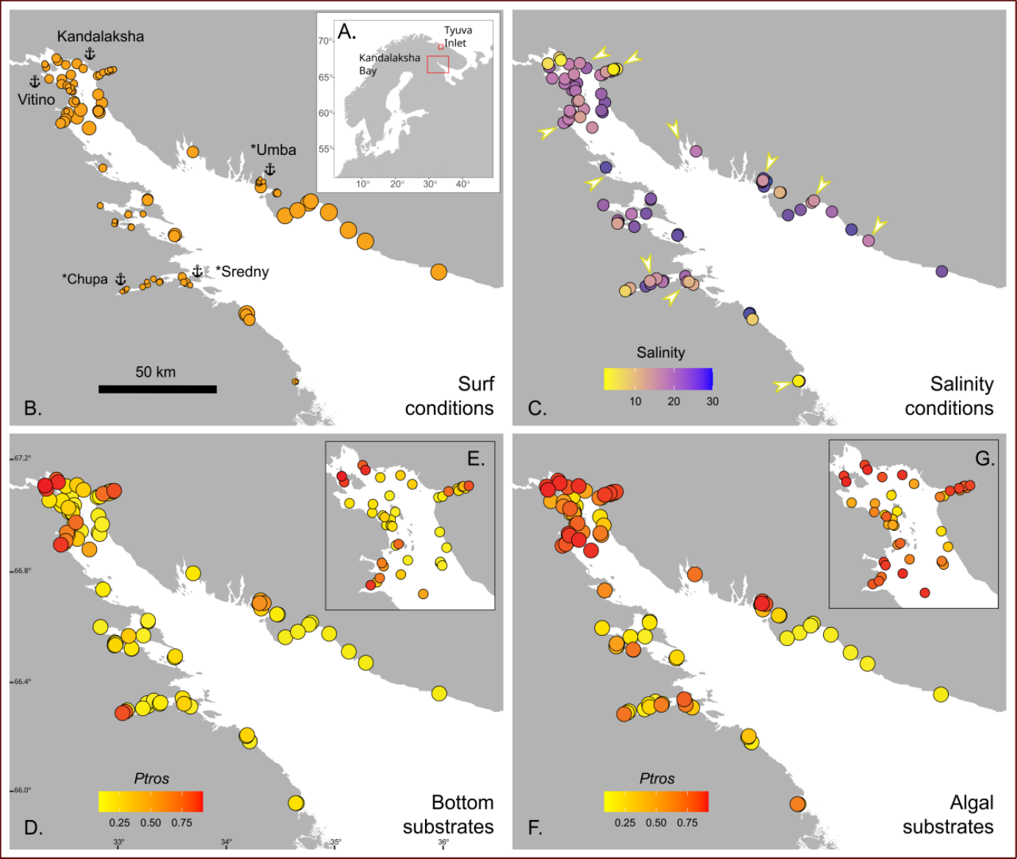

Figure 1. Taxonomic structure of mussel settlements and their habitat characteristics. (A) Map of Northern Europe. Red boxes mark the position of Kandalaksha Bay and Tyuva Inlet. Maps i B-G represent the Kandalaksha Bay. Land is shown in, grey, sea is shown in white. (B) Surf conditions. Point size is proportional to Fetch. Anchors with names mark ports. Asterisks identify whether the port is currently abandoned. (C) Salinity conditions. Point filling is proportional to Salinity. Arrows mark mouths of large rivers. (D-G) Proportion of MT in bottom (Ptros_{Bottom}, D-E) and algal (Ptros_{Algae}, F-G) samples. Point filling is proportional to Ptros. E and G show the Bay’s top in higher resolution.
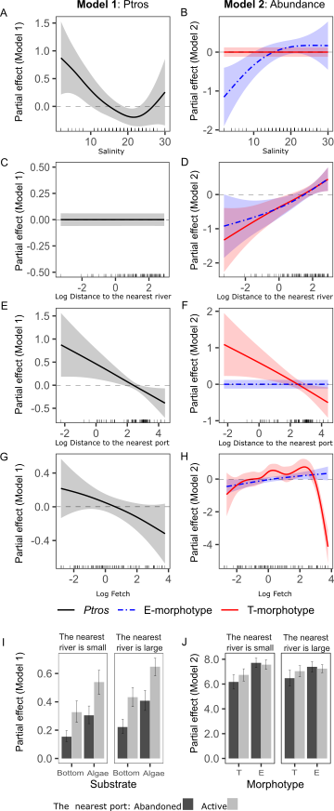
Figure 2. Partial effects of environmental parameters on either proportion of M. trossulus in mixed settlements (Ptros) or abundance of species-specific morphotypes evaluated by GAM(M)s fitted (Model 1 and Model 2, respectively). Dependency of Ptros on salinity at low tide (Salinity, A), distance to the nearest river (DistRiver, C), distance to the nearest port (DistPort, E), wind exposure (Fetch, G), and discrete predictors: substrate type, nearest port status and size of the nearest river (I). Dependency of E- and T-morphotype log-transformed abundances on Salinity (B), DistRiver (D), DistPort (F), Fetch (H), and nearest port status and size of the nearest river (J). Ribbons around curves and whiskers represent 95% confidence intervals.

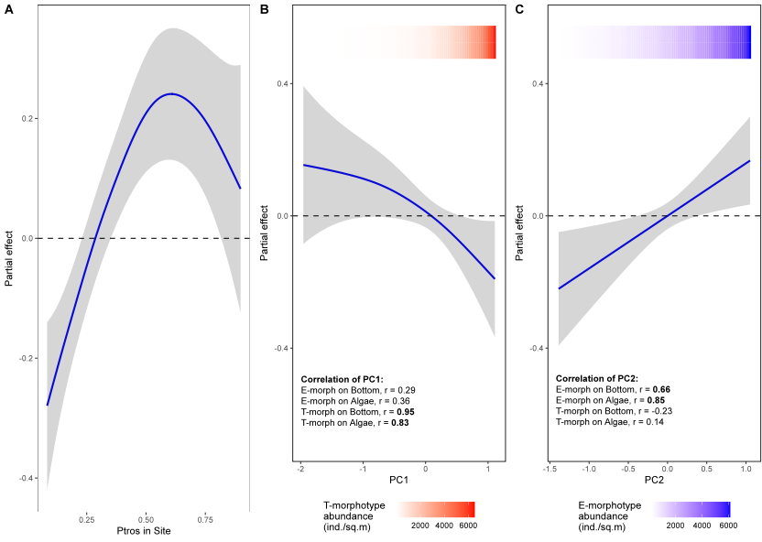

Figure 3. The dependence of difference between proportion of MT on algal and bottom substrates (Diff) on proportion of MT in a site (Ptros_{Site}) (A) and estimations of total abundance of MT (B) and ME (C). Principal components from the matrix of T- and E-morphotypes abundances on different substrates are considered as proxies for MT and ME abundances (PC1 and PC2, respectively). Correlations of mussel abundances with PC scores are given, two highest coefficients are given in bold. Ribbons around curves represent 95% confidence intervals. Colored gradient bars at the top of the figures reflect linear associations between PC1 and T-morphotype (B) and PC2 and E-morphotype abundance (C).
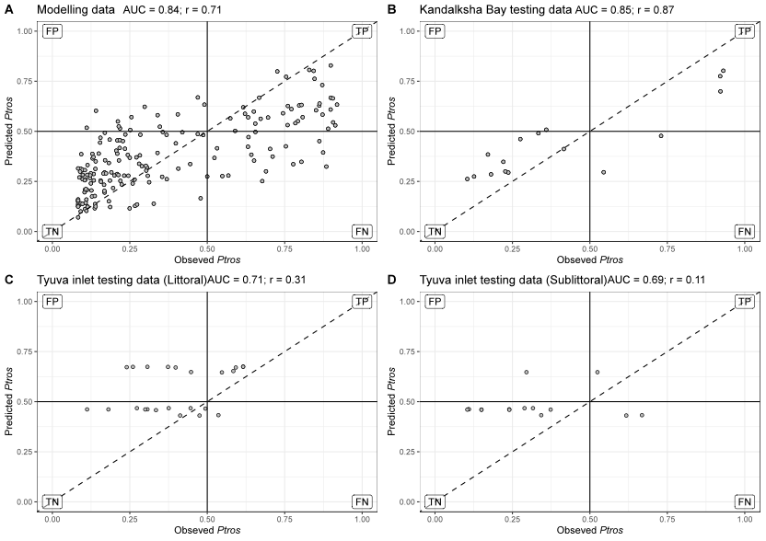

Figure 4. Ability of SDM (Model 1) to predict proportion of MT (Ptros) in mussel samples from the modeling (A) and the testing datasets (B-D). Each plot compares empirical Ptros in samples from algal and bottom substrates and Ptros predicted by the model within the particular dataset. If the empirical and the predicted values were the same, the points would lie on the diagonal (dashed line). Labels mark the quadrants with false positive (FP), true positive (TP), true negative (TN) and false negative (FN) predictions in the analysis of the ability of the model to classify samples into ME-dominated (Ptros < 0.5) and MT-dominated (Ptros >0.5) ones. Dataset names are shown in chart headers. Values of AUC for binary classification (ME-dominated vs MT-dominated) and Pearson correlations between observed and predicted Ptros are given in figure headings.

